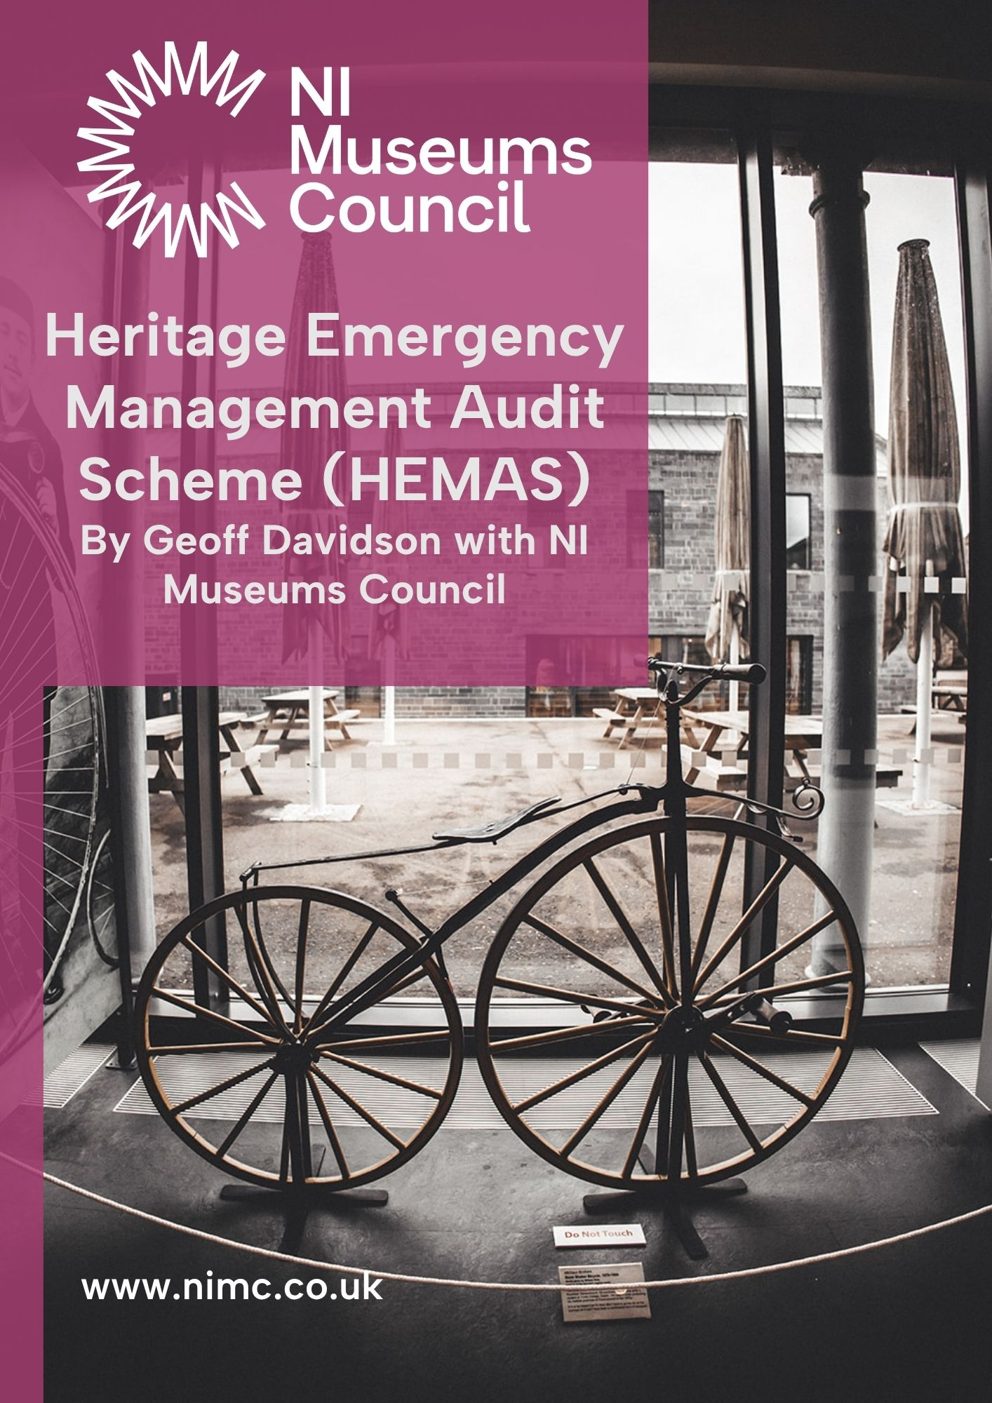

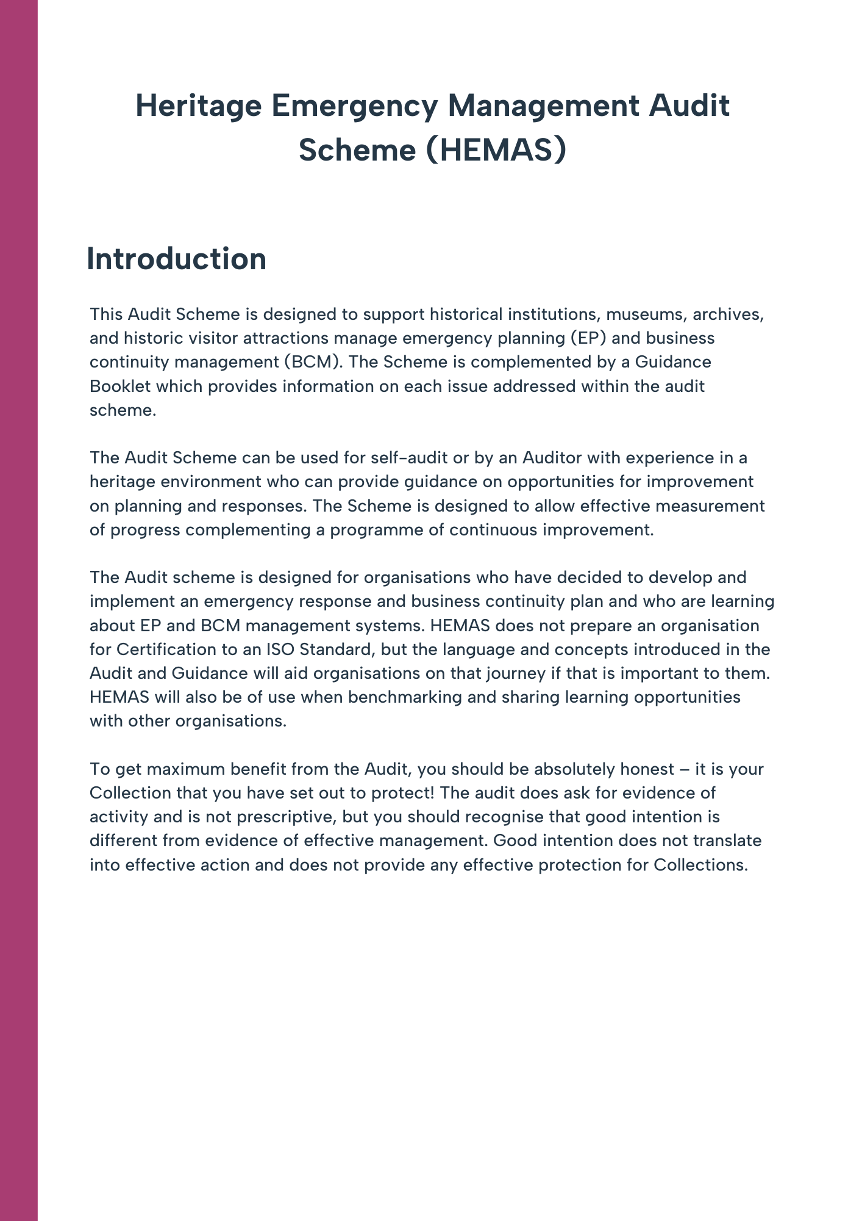

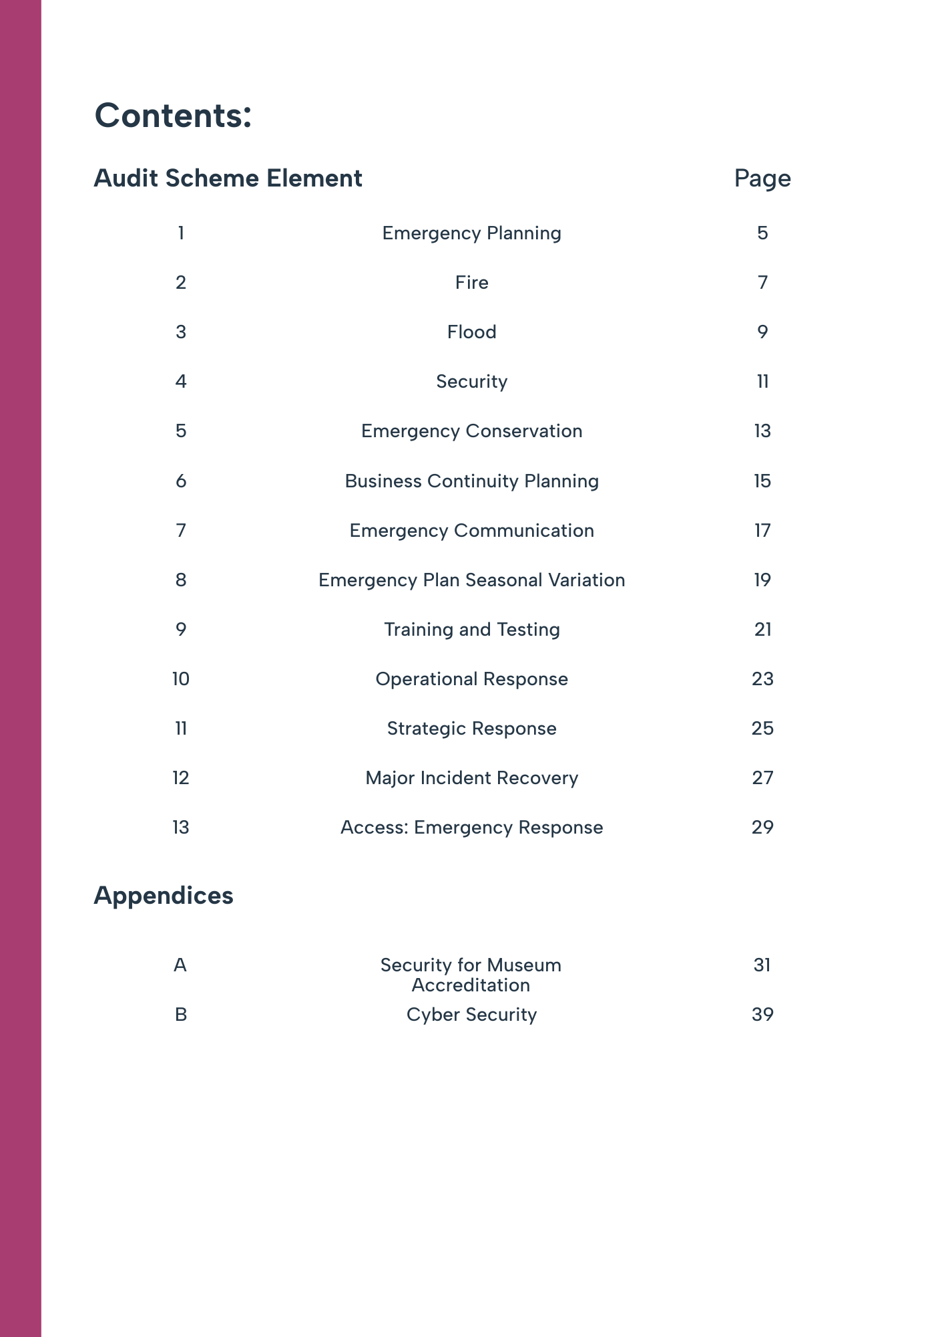

HEMAS: Audit Scheme Element 1
Emergency Planning
 |  |  |  | 1 |  | 2 |  |  | 3 |  | 4 |  | 5 | Score
1.01 | Do you have an emergency plan for your organisation?
1.02 | Have you considered a range of potential emergencies and assessed their risk? Does the Emergency Plan enable staff to respond in the event of theft, fire, and flood as a minimum? (This is a Museum Accreditation requirement)
1.03 | Does the Plan include arrangements for staff, volunteers, visitors, collections, and collections information?
1.04 | Do staff know when to declare an emergency?
1.05 | Is your plan readily available to staff?
1.06 | Is your plan held in a place which is accessible during an emergency?
1.07 | Does your plan identify your Response Team?
1.08 | Have the Response Team members been trained in their roles?
1.09 | Do you know how to contact these individuals in an emergency?
1.10 | Do you know how long it will take for them to get to your site in an emergency?
1.11 | Do these individuals know that they will be contacted in an emergency?
1.12 | Do you know what emergency response equipment you need?
1.13 | Do you know how to get hold of emergency response equipment when you need it?
1.14 | Have you identified any priority objects you want to move and how they can be moved?
1.15 | Do you know who will move these objects?
1.16 | Do you know where the objects will go after they have been moved?
1.17 | Do you know who to ask for advice on building damage and recovery?
1.18 | Do you have a programme for testing your emergency plans regularly?
1.19 | Do you review your plan annually; after an incident or following testing?
1.20 | Has someone been appointed to authorise the Plan and revisions?
1.21 | Once the Plan has been authorised, tested, reviewed, and updated is it made available to staff and the Emergency Services
1.22 | If you share a building with another organisation, have you reviewed links to their plan?
Element 1: Total Score

Auditors Notes Section 1:  Emergency Planning |  |  |  |  | % Compliance =
Evidence reviewed includes:

Max Score available: |  | 110 |  | Auditor Name:
Element Score Achieved: |  |  |  | Audit Date:
% Compliance with Audit Element 1
% Compliance achieved = Score Achieved/Max Score available x 100
Auditor Recommendations |  |  |  |  |  | Date for action to be completed
R 1.1
R 1.2
R 1.3

HEMAS: Audit Scheme Element 2
Fire

NI Fire and Rescue Service |  | 1 |  | 2 |  | 3 |  | 4 | 5 | Score
2.01 | Does the Fire and Rescue Service know about your Collection and buildings?
2.02 | Does the Fire Service know how to find your buildings in the event of an emergency?
2.03 | Do you arrange for Fire Service familiarisation visits to your site?
2.04 | Does your Collection contain materials which increase risks for fire fighters?
2.05 | Do your buildings or Collection require a specific response from the Fire Service?
2.06 | Have you completed a site-specific risk assessment with the Fire Service?
2.07 | Are staff aware of how to raise the alarm with the Fire Service?
2.08 | Have you discussed the implications of fire, smoke, extinguishing medium and salvage on your Collection with the Fire Service?
2.09 | Does the Fire Service have plans for your site indicating your key priorities?
2.10 | Are there any restrictions on the types of firefighting materials which may be used on your Collection?
2.11 | Do you include the Fire Service in your testing programme?
Fire Plan
2.12 | Do you have a Fire Plan for your buildings?
2.13 | Have you a fire risk assessment for the premises and your use of the premises?
2.14 | Do you have a Fire Safety Policy?
2.15 | Do you regularly review and update your Fire Safety Policy?
2.16 | Do you have a fire detection and alarm system?
2.17 | Is your fire detection and alarm system regularly inspected, maintained, and tested?
2.18 | Do you keep a record of the frequency of alarm tests including the call point used to initiate the alarm, audibility of alarm sounders and fire panel notification?
Element 2: Total Score

Auditors Notes Element 2:  Fire |  |  |  |  | % Compliance =
Evidence of reviewed includes:

Max Score available: |  |  | 90 | Auditor Name:
Element Score Achieved: |  |  |  | Audit Date:
% Compliance with Audit Element 2
% Compliance achieved = Score Achieved/Max Score x 100
Auditor Recommendations |  |  |  |  |  | Date for action to be completed
R 2.1
R 2.2
R 2.3

HEMAS: Audit Scheme Element 3
Flood

 |  | 1 |  | 2 |  | 3 |  | 4 | 5 | Score
3.01 | Have you reviewed the Dept. for Infrastructure Rivers and Flooding Strategic Flood Maps in relation the flood risk to your buildings?
3.02 | Have you identified areas likely to be affected by internal piped/stored water systems?
3.03 | Have you identified areas likely to be affected by rainwater ingress?
3.04 | Do you regularly inspect risk areas for blocked/damaged gutters, drains, etc.?
3.05 | Have you identified areas, including internal, likely to be affected by an external flood?
3.06 | Do you have you a planned flooding response for high risk areas?
3.07 | Do you have any means of diverting flooding to protect spaces?
3.08 | Are vulnerable objects identified and stored to minimise potential flood damage?
3.09 | Do you have specified/allocated areas for storage and restoration of wet objects and specimens?
3.10 | Have you identified organisations who may be able to offer guidance and advice in the event of a flood?
Element 3: Total Score

Auditors Notes Element 3:  Flood |  |  |  |  | % Compliance =
Evidence reviewed includes:

Max Score available: |  |  | 50 | Auditor Name:
Score Achieved: |  |  |  | Audit Date:
% Compliance with Audit Element 3
% Compliance achieved = Score Achieved/Max Score x 100
Auditor Recommendations |  |  |  |  |  | Date for action to be completed
R 3.1
R 3.2
R 3.3

HEMAS: Audit Scheme Element 4
Security

 |  |  |  |  |  | 1 |  | 2 |  |  | 3 |  | 4 |  | 5 | Score
4.01 |  | Is the Police Service aware of your location and the nature of your building and Collection?
4.02 |  | Have you discussed security, including arson and vandalism, with your Police Crime Prevention Officer (CPO)?
4.03 |  | Are you in regular contact with the CPO?
4.04 |  | Have you asked the CPO and insurers to review your security arrangements?
4.05 |  | Have you discussed arson and arson mitigation with the Fire Service?
4.06 |  | Have you discussed Collections security with your Insurers?
4.07 |  | Have you reviewed access points to your buildings, e.g., windows and doors away from public view and dark areas?
4.08 |  | Do you have an access control system for business visitors?
4.09 |  | Do you have a security alarm system?
4.10 |  | Is your alarm system maintained, inspected, and tested regularly?
4.11 |  | Do you have a planned response when the security alarm goes off?
4.12 |  | Do you keep up to date with Museum/Collections crime?
4.13 |  | Do you have you a Security Policy?
4.14 |  | Do you review your Security Policy regularly?
4.15 |  | Have you a Security Risk Assessment for your premises and Collection?
4.16 |  | Do you complete a Security Risk Assessment for temporary exhibitions?
4.17 |  | Do you review the Security Risk Assessment following an incident to establish any lessons learnt?
Element 4: Total Score
Auditors Verification Notes Element 4:  Security |  |  |  |  |  |  |  |  |  | % Compliance =
Evidence reviewed includes:

Max Score available: |  |  |  | 85 | Auditor Name:
Score Achieved: |  |  |  |  | Audit Date:
% Compliance with Audit Element 4
% Compliance achieved = Score Achieved/Max Score x 100
Auditor Recommendations |  |  |  |  |  |  |  |  |  |  |  |  |  | Date for action to be completed
R 4.1
R 4.2
R 4.3

HEMAS: Audit Scheme Element 5
Emergency Conservation

 |  | 1 |  | 2 |  | 3 |  | 4 | 5 | Score
5.01 | Have you identified priority objects which can be moved in an emergency?
5.02 | Have you identified and trained those people will move the object in an emergency?
5.03 | Have you considered how to protect priority objects which cannot be moved?
5.04 | have you identified a competent person to triage object damage for you?
5.05 | Have you identified specialised conservators to establish that they are aware of your Collections and how they can help, including outside normal working hours?
5.06 | Do you know what materials and equipment you need for emergency conservation?
5.07 | Do you know where you can get the materials and equipment you need for emergency conservation?
5.08 | Have you established emergency conservation procedures for your Collections?
5.09 | Have you identified secure places for triage, treatment, and storage of objects?
5.10 | Have you considered the long-term security of objects moved from their normal location?
Element 5: Total Score

Auditors Notes Element 5:  Security |  |  |  |  | % Compliance =
Evidence reviewed includes:

Max Score available: |  |  | 50 | Auditor Name:
Score Achieved: |  |  |  | Audit Date:
% Compliance with Audit Element 5
% Compliance achieved = Score Achieved/Max Score x 100
Auditor Recommendations |  |  |  |  |  | Date for action to be completed
R 5.1
R 5.2
R 5.3

HEMAS: Audit Scheme Element 6
Business Continuity Planning

 |  | 1 |  | 2 |  | 3 |  | 4 | 5 | Score
6.01 | Have you identified the critical needs of your organisation, including non-collections needs, e.g. finance?
6.02 | Have you considered what threats can affect your critical activities?
6.03 | Have you planned how you will deal with incidents which affect your critical activities including return to service requirements?
6.04 | Have you investigated and considered mutual aid arrangements for critical activities with similar organisations?
6.05 | Have you planned how you will deal with a loss of staff in a business-critical area?
6.06 | Have you planned how to deal with a loss of workspace in a business-critical area?
6.07 | Have you planned how to deal with a loss of IT systems in a business-critical area?
6.08 | Have you plans to communicate changing circumstances to staff, stakeholders, visitors, and media?
6.09 | Do you review your Business Continuity (BC) plans regularly?
6.10 | Do you regularly review sources of information to identify new threats or risks to your activities?
6.11 | Do you use social media to communicate? The BC Plan should Include instructions on which platform to use and the need for approval of the message to be published by the Incident Management Team.
6.12 | Is someone appointed to review and authorise all media and social media communications?
Element 6: Total Score

Auditors Notes Element 6:  Emergency Planning |  |  |  |  | % Compliance =
Evidence reviewed includes:

Max Score available: |  |  | 60 | Auditor Name:
Score Achieved: |  |  |  | Audit Date:
% Compliance with Audit Element 6
% Compliance achieved = Score Achieved/Max Score x 100
Auditor Recommendations |  |  |  |  |  | Date for action to be completed
R 6.1
R 6.2
R 6.3

HEMAS: Audit Check Element 7
Emergency Communication

 |  | 1 |  | 2 |  | 3 |  | 4 | 5 | Score
7.01 | Have you a contact list for those people who will be involved in any emergency response?
7.02 | Do you regularly review the list to ensure that it is up to date?
7.03 | Does the list include contractors you may need only in an emergency?
7.04 | Do you test your contacts list regularly?
7.05 | Have you tested your staff emergency communication plans?
7.06 | Have you established how you will communicate with stakeholders, visitors, and the media?
7.07 | Do you have agreed content and approval protocols for using social media in an emergency?
Element 7: Total Score

Auditors Notes Element 7:  Emergency Communication |  |  |  |  | % Compliance =
Evidence reviewed includes:

Max Score available: |  |  | 35 | Auditor Name:
Score Achieved: |  |  |  | Audit Date:
% Compliance with Audit Element 7
% Compliance achieved = Score Achieved/Max Score x 100
Auditor Recommendations |  |  |  |  |  | Date for action to be completed
R 7.1
R 7.2
R 7.3

HEMAS: Audit Check Element 8
Emergency Plan Seasonal Variation

 |  | 1 |  | 2 |  | 3 |  | 4 | 5 | Score
8.01 | Does your emergency plan consider seasonal variability and climate change?
8.02 | Have you considered prolonged periods of exceptionally low or high temperatures?
8.03 | Have you considered prolonged periods of low or high humidity?
8.04 | Have you considered the impact of regular storms?
8.05 | Have you considered wet weather prevention /precautions?
8.06 | Do you inspect buildings looking for blocked drains, gutters, etc. regularly throughout the year?
8.07 | Do you regularly check that your weather precautions will continue to work?
Element 8: Total Score

Auditors Notes Element 8:  Emergency Plan Seasonal Variation |  |  |  |  | % Compliance =
Evidence reviewed includes:

Max Score available: |  |  | 35 | Auditor Name:
Score Achieved: |  |  |  | Audit Date:
% Compliance with Audit Element 8
% Compliance achieved = Score Achieved/Max Score x 100
Auditor Recommendations |  |  |  |  |  | Date for action to be completed
R 8.1
R 8.2
R 8.3

HEMAS: Audit Check Element 9
Training and Testing

Training |  | 1 |  | 2 |  | 3 |  | 4 | 5 | Score
9.01 | Have you reviewed and established the training requirements of your Emergency Plan?
9.02 | Do you have a training programme for your Emergency Plan?
9.03 | Do you have a schedule for regular staff training?
9.04 | Do you include staff with stand-in roles within the training and testing programme?
9.05 | Have you reviewed the training needs of non-operations staff who may be involved in a major incident?
9.06 | Have you discussed training with the Fire Service?
Testing
9.07 | Do you test your emergency plan regularly?
9.08 | Do you carry out tabletop exercises with staff?
9.09 | Do you carry out exercises in real time?
9.10 | Do you review the training and exercises with staff after the teat?
9.11 | Do you involve the emergency services in your exercises?
Element 9: Total Score

Auditors Notes Element 9:  Training and Exercising |  |  |  |  | % Compliance =
Evidence reviewed includes:

Max Score available: |  |  | 55 | Auditor Name:
Score Achieved: |  |  |  | Audit Date:
% Compliance with Audit Element 9
% Compliance achieved = Score Achieved/Max Score x 100
Auditor Recommendations |  |  |  |  |  | Date for action to be completed
R 9.1
R 9.2
R 9.3

HEMAS: Audit Check Element 10
Operational Response

 |  | 1 |  | 2 |  | 3 |  | 4 | 5 | Score
10.01 | Have you established criteria for declaring a major incident?
10.02 | Have you established who will declare an incident as a ‘major incident’?
10.03 | Are you aware of the emergency services major incident protocols?
10.04 | Is a member of the response team designated as the contact person for the emergency services when they arrive?
10.05 | Are incident response staff aware of the location of emergency response equipment and materials and how to access it?
10.06 | Are staff trained in how to use emergency response equipment?
10.07 | Is your emergency response equipment regularly maintained, inspected, and tested?
10.08 | Do all staff know that all communication outside the organisation should be done by the Incident Management Team only?
Element 10: Total Score

Auditors Notes Element 10:  Operational Response |  |  |  |  | % Compliance =
Evidence reviewed includes:

Max Score available: |  |  | 40 | Auditor Name:
Score Achieved: |  |  |  | Audit Date:
% Compliance with Audit Element 10
% Compliance achieved = Score Achieved/Max Score x 100
Auditor Recommendations |  |  |  |  |  | Date for action to be completed
R 10.1
R 10.2
R 10.3

HEMAS: Audit Check Element 11
Strategic Response

 |  | 1 |  | 2 |  | 3 |  | 4 | 5 | Score
11.01 | Have you identified the implications of a major incident for your Collections and activities?
11.02 | Have you identified a major incident management team to support your emergency incident responders?
11.03 | Have you established how your management team will communicate with each other during a major incident?
11.04 | Is the major incident management team aware of their roles in a major incident?
11.05 | Does your management team know how to communicate with stakeholders?
11.06 | Have you prepared a holding statement for the media and nominated a spokesperson?
11.07 | Do you know how to contact your insurers in an emergency?
11.08 | Do you know how to authorise expenditure during a major incident?
11.09 | Do you have arrangements to provide refreshments for staff during a major incident?
11.10 | Do you ensure that staff have rest breaks during an incident?
11.11 | Do you arrange for staff to get home safely if they are tired following after an incident?
11.12 | Do you know how you will communicate with visitors and guests during and after the incident?
Element 11: Total Score

Auditors Notes Element 11:  Strategic Response |  |  |  |  | % Compliance =
Evidence reviewed includes:

Max Score available: |  |  | 60 | Auditor Name:
Score Achieved: |  |  |  | Audit Date:
% Compliance with Audit Element 11
% Compliance achieved = Score Achieved/Max Score x 100
Auditor Recommendations |  |  |  |  |  | Date for action to be completed
R 11.1
R 11.2
R 11.3

HEMAS: Audit Scheme Element 12
Major Incident Recovery

 |  | 1 |  | 2 |  | 3 |  | 4 | 5 | Score
 | Recovery: People
12.01 | Do you have a plan to debrief people as soon as practical to establish the incident timeline and response?
12.02 | Do you have a plan to bring small groups of people involved together to discuss their concerns, feelings and establish how post incident stress might affect them?
12.03 | Have you appointed someone to act as Facilitator for these groups?
12.04 | Does the management team collate the debrief comments and confirm lessons learnt, make recommendations, and establish a programme for implementation?
12.05 | Do you discuss the incident and learning opportunities with the responding emergency services?
12.06 | Do you discuss lessons learnt and responses with the responding emergency services?
 | Recovery: Equipment
12.07 | Have you established what equipment is critical to your operations and have arrangements to maintain and inspect it for return to service where it was affected during the incident?
12.08 | Do you have a plan to replace, maintain and inspect equipment affected by the incident?
12.09 | Do you review the effectiveness of equipment involved in the incident response?
 | Recovery: Materials
12.10 | Do you replace materials used in the incident as soon as practicable?
12.11 | Do you review the quantity and effectiveness of materials used in the incident response?
 | Recovery: Environment
12.12 | Do you consider any potential contamination created by the incident or the materials used to control it?
12.13 | Do you undertake risk assessment in advance of an incident to establish control measures for treating and reoccupying spaces?
12.14 | Have you considered the environmental impact of materials used in the incident response being released from your site?
Element 12: Total Score

Auditors Notes Element 12:  Strategic Response |  |  |  |  | % Compliance =
Evidence reviewed includes:

Max Score available: |  |  | 70 | Auditor Name:
Score Achieved: |  |  |  | Audit Date:
% Compliance with Audit Element 12
% Compliance achieved = Score Achieved/Max Score x 100
Auditor Recommendations |  |  |  |  |  | Date for action to be completed
R 12.1
R 12.2
R 12.3

HEMAS: Audit Scheme Element 13
Access: Emergency Response

 |  | 1 |  | 2 |  | 3 |  | 4 | 5 | Score
13.01 | Do you have a programme in place to establish the access needs of staff, visitors, and volunteers?
13.02 | Do you develop Personal Emergency Evacuation Plans (PEEPs) for staff, visitors, and volunteers?
13.03 | Do the PEEPS address sensory, learning, and neurodivergent disabilities?
13.04 | Are staff made aware of the contents of the PEEPS?
13.05 | Does your emergency response signage reflect the needs of disabled people?
13.06 | Have evacuation routes and assembly points been reviewed to meet the needs of disabled people?
13.07 | Have you reviewed your PEEPs with disabled people, including staff and visitors?
13.08 | Do you include disabled people in practice emergency responses?
13.09 | Do you consider the needs of disabled people when planning events? Including refuges for those temporarily unaccompanied.
13.10 | Do you include disability access in major incident response reviews?
Element Appendix C: Total Score

Auditors Notes Element Appendix C  Access: Emergency Response |  |  |  |  | % Compliance =
Evidence reviewed includes:

Max Score available: |  |  | 50 | Auditor Name:
Score Achieved: |  |  |  | Audit Date:
% Compliance with Audit Element B
% Compliance achieved = Score Achieved/Max Score x 100
Auditor Recommendations |  |  |  |  |  | Date for action to be completed
R 13.1
R 13.2
R 13.3

Appendix A
Security Audit Museum Accreditation

This Audit element compliments Audit Element 4: Security by providing a standard which is useful in assessing security management performance for Museum accreditation. The Audit is based on the document ‘Security in museums and galleries: the Security Audit Arts Council England 2022’ which is the primary document and guidance for Accreditation. The HEMAS Audit Scheme is designed to provide a quantitative outcome highlighting areas for improvement and satisfactory performance.

HEMAS: Audit Scheme Element Appendix A (Museum Accreditation)
Security

 |  | 1 |  | 2 |  | 3 |  | 4 | 5 | Score
Security Resources
A.01 | Is the Police Service aware of your location and the nature of your building and Collection?
A.02 | Have you discussed security, including arson and vandalism, with your Police Crime Prevention Officer (CPO)?
A.03 | Are you in regular contact with the CPO?
A.04 | Have you asked the CPO and insurers to review your security arrangements?
A.05 | Have you discussed arson and arson mitigation with the Fire Service?
A.06 | Have you discussed Collections security with your Insurer?
Building Security
A.07 | Are all outbuildings kept secure and locked?
A.08 | Have you reviewed access points to your buildings, e.g., windows and doors away from public view and dark areas?
A.09 | Do you check for damage to the walls of buildings with attention to prefabricated or metal clad sections?
A.10 | Do you check for roof damage, as far as it safe to do so?
A.11 | Are all doors, windows, and other openings secure? Paying attention to external screens, bars or grilles on doors or windows
A.12 | Do you check regularly for damaged glazing?
A.13 | Are all door and window hinges, frames, and fixings secure and intact?
A.15 | Do you regularly check for signs of criminal reconnaissance or activity?
A.16 | Are your physical security arrangements visible to someone outside your building? This may be in the form of signs, alarms, or security staff.
External environment
A.17 | Are bins and refuse containers secured to prevent them being used as climbing aids?
A.18 | Is litter regularly cleared away?
A.19 | Are items in the grounds, or outside the building that may increase the risk of arson secured?
A.20 | Are heavy pieces of infrastructure, such as benches, which could be used to gain entrance secured?
A.21 | Do you check regularly for signs of criminal reconnaissance or activity?
A.22 | Do you check regularly for damage to external security lighting and cabling?
A.23 | Do you check external security lighting operation including devices such as dusk to dawn sensors or Passive Infrared Devices (PIR) that are used to control lighting?
A.24 | Do you check for damage to CCTV cameras and exposed cabling?
A.25 | Does external lighting (PIR or otherwise) illuminate all external doors, windows, and entrances to the building?
A.26 | Does the CCTV system record decent quality images taken in darkness?
A.27 | Are external intruder alarms visible?
A.28 | Are external intruder alarms working?
A.29 | Are external intruder alarms audible when activated?
A.30 | Are all external doors, windows and entrances to the building protected by intruder alarms?
Internal Environment
A.31 | Is the Reception area well lit?
A.32 | Does the reception desk have full sight of the main entrance?
A.33 | Is there a remote locking function for the main entrance? Is it tested regularly?
A.34 | Is there a panic alarm at the reception desk? Is it tested regularly?
A.35 | Are there clear lines of sight from the reception desk to display areas?
A.36 | Do security doors have devices such as door chains/viewers for use when the museum is closed to the public?
A.37 | Are all non-cased objects secured and protected?
A.38 | Is there a visible staff presence in display areas, particularly where vulnerable objects are displayed?
A.39 | Are back of house areas which contain vulnerable objects obscured from view?
Storage
A.40 | Are storage containers identified by a numbering system which relates to your object records?
A.41 | Are all containers supervised when outside a secure storage area?
CCTV
A.42 | Are the entrances covered by CCTV?
A.43 | Is signage clearly visible which advises that security systems and CCTV are in use?
Security Alarms
A.44 | Are all intruder alarms, include those inside cases, regularly checked and tested?
A.46 | Is the alarm backup system, used in the event of power failure, in working order and checked regularly?
Access Control
A.47 | Do you have a pass system for all staff and visitors?
A.48 | Are doors to all stores, and non-visitor areas secured?
A.49 | Are staff/visitors always accompanied when entering areas holding high value objects, or objects of interest to a thief?
A.50 | Are visitors with bags and coats screened on entry, and do you have a size of bags policy?
Security Systems
A.51 | Do you have a security alarm system?
A.52 | Is the alarm system inspected, maintained, and tested regularly?
A.53 | Do you have a planned response when the security alarm goes off?
A.54 | Are staff trained in the security responses?
Security Management
A.55 | Do you keep up to date with Museum/Collections crime?
A.56 | Do you have you a Security Policy?
A.57 | Do you review your Security Policy regularly?
A.58 | Have you a Security Risk Assessment for your premises and Collection?
A.59 | Do you complete a Security Risk Assessment for temporary exhibitions?
A.60 | Do you review your Security Risk Assessment regularly and after any incident irrespective of any loss or damage?
A.61 | Have you implemented recommendations from the Security Risk Assessment?
A.62 | Do you have a schedule for regular Environmental Visual Assessments (EVAs)?
A.63 | Do all staff take part in Environmental Visual Assessments?
A.64 | Do all staff take part in security awareness training?
A.65 | Is responsibility for the security of the collections reflected in all staff job descriptions and/or volunteer agreements?
A.66 | Is security regularly discussed at staff meetings?
A.67 | Is security a part of the induction process for all staff?
A.68 | Do staff have access to information about security issues from external sources?
A.69 | Have you identified appropriate security standards for external doors windows, skylights, grilles, bars, shutters, and locks? For external doors and windows include including frames, glazing and locks. Include external doors that are fire escapes.
A.70 | Have you identified appropriate security standards for internal doors, windows or skylights bars, shutters, or grilles? Include frames, glazing hinges and locks. Include doors to collections stores.
A.71 | Do your external and internal doors, windows or skylights bars, shutters or grilles meet the standards you have identified?
A.72 | Have you identified appropriate specifications for all museum cabinets and cases? Include frames, glazing, locks, hinges, and case construction.
A.73 | Do all your display cabinets and cases comply with the security standards you have identified?
A.74 | Have you assessed and identified appropriate standards for CCTV provision inside your building?
A.75 | Have you implemented these standards for CCTV provision inside your building?
A.76 | Have you assessed and identified standards for appropriate intruder alarm provision inside your building? Include alarms for internal doors, and cases, and vibration sensors in cases
A.77 | Have you implemented the standards for intruder alarms that you have identified?
A.78 | Have you identified appropriate security standards for external lighting, intruder alarms and CCTV?
A.79 | Does the external lighting, intruder alarms and CCTV comply with the standards you identified?
A.80 | Have you identified appropriate standards for storage containers for high value objects, or objects which might be of interest to a thief? This should include frames, glazing, locks, hinges, and case construction.
A.81 | Do all your containers for high value objects comply with the security standards you identified?
Maintenance and Inspection
A.82 | Do you have regular and frequent building inspection schedules?
A.83 | Are building inspections scheduled logged and recorded for audit?
A.84 | Do you have regular and frequent gallery and stores inspection schedules?
A.85 | Is all electrical wiring installed in accordance with the appropriate British Standard and statutory regulations?
A.86 | Is all electrical wiring maintained checked and logged regularly by a competent person?
A.87 | Is all electrical, gas and oil equipment installed in accordance with the appropriate British Standard and statutory regulations?
A.88 | Is all electrical, gas and oil equipment maintained checked and logged regularly by a competent person?
A.89 | Do you have regular and frequent housekeeping schedules?
A.90 | Are housekeeping schedules logged?
A.91 | Do you have regular and frequent tests of theft and fire alarms? Include sensor alarms in cases
A.92 | Are tests of theft and fire alarms logged?
A.93 | Do you have regular and frequent tests of CCTV equipment?
A.94 | Are tests of CCTV equipment logged and recorded for audit?
A.95 | Do you have a procedure for checking the quality of CCTV images?
Key Control
A.96 | Do you have a key tracking system, which identifies at any time all individuals who are holding keys?
A.97 | Is key control the responsibility of named individuals?
A.98 | Other than keys needed to open the building is a system to prevent keys ever being removed from the building after closing?
A.99 | Are keys issued to staff for museum related activity only?
Security Advice
A.100 | Have you identified individuals who can provide you with specialist advice about crime and criminal activity?
Security Contracts
A.101 | Is any part of your security provision (such as out of hours call outs, alarm responses, after hours security presence) contracted out to another organisation, or the responsibility of another organisation?
A.102 | Do you have a Service Level agreement with that organisation?
A.103 | Is the SLA reviewed frequently and regularly, and informed by the results of EVAs and Security Checks?
Element Appendix A Museum Security: Total Score

Auditors Notes Element Appendix A  Security for Accreditation: |  |  |  |  | % Compliance =
Evidence reviewed includes:

Max Score available: |  |  | 515 | Auditor Name:
Score Achieved: |  |  |  | Audit Date:
% Compliance with Audit Element B
% Compliance achieved = Score Achieved/Max Score x 100
Auditor Recommendations |  |  |  |  |  | Date for action to be completed
R A.1
R A.2
R A.3

Appendix B
Cyber Security

This Audit element addresses the issue of cyber security and is based on the National Cyber Security Centre guidance for Small Business. Information and guidance on Cyber Security is available from the National Cyber Security Centre.

HEMAS: Audit Scheme Element Appendix B
Cyber Security

 |  | 1 |  | 2 |  | 3 |  | 4 | 5 | Score
Data Security
B.01 | Have you identified business critical data?
B.02 | Do you regularly backup business critical data?
B.03 | Do you keep the backed-up data separate from computers?
B.04 | Is backed up data inaccessible to staff?
B.05 | Is backing up critical data routine within the organisation?
Protecting the Organisation from Malware
B.06 | Have you switched on antivirus protection built into the software you use?
B.07 | Have you installed antivirus software for your systems?
B.08 | Are staff aware that they should not download software or Apps?
B.09 | Are Administrators the only people who can give permission for downloads and App installation?
B.10 | Do staff accounts have sufficient access to allow performance of their role only?
B.11 | Are staff with smartphones and tablets aware that Apps must not be downloaded from unknown vendors/sources?
B.12 | Are all Firewalls switched on?
Keeping all IT Equipment Up to Date (Patching)
B.13 | Do you ensure that all IT equipment is kept up to date with latest versions from software developers, hardware suppliers and vendors?
B.14 | Have you established automatic updates for patching?
Control of USB Devices
B.15 | Do you block/deny physical access to USB connectors for most users?
B.16 | Do you provide approved USB drives for use on your systems and nowhere else?
Keeping Smartphones and Tablets safe
B.17 | Is password protection switched on for all devices?
B.18 | Is fingerprint recognition enabled on all devices?
B.19 | Can lost or stolen devices be tracked, locked, or wiped?
B.20 | Are regular security updates for device carried out?
B.21 | Are regular App updates for new features and patches carried out?
B.22 | Are users aware that they should not connect to unknown Wi-Fi hotspot and should use 3G or 4G networks?
Using Passwords to Protect Data
B.23 | Is Password protection switched on, including screen lock, PIN, biometrics, for all smartphones, tablets, and critical office equipment?
B.24 | Is 2-Step Verification used for important accounts?
B.25 | Are staff trained how to avoid predictable passwords?
B.26 | Are staff aware that passwords should not be shared?
B.27 | Do you provide guidance for staff on how to manage ‘password overload’?
B.28 | Do you change manufacturers default passwords on new equipment before it comes into service?
Avoiding Phishing Attacks
B.29 | Are Accounts configured to reduce the impact to successful Phishing attacks?
B.30 | Is browsing from Administrator accounts prohibited?
B.31 | Have you discussed with staff how you might be attacked? Including how to recognise unusual and suspicious requests
B.32 | Are staff aware how to get advice on unusual requests?
Reporting Attacks
B.33 | Are staff aware that they should seek help immediately they suspect they may have been a victim?
B.34 | Do you report all attacks through the ‘Action Fraud’ website?
Checking your Digital Footprint
B.35 | Have you reviewed what information can be gleaned from your website and social media accounts which might be of use in an attack?
B.36 | Are staff aware of what information they may share with others and how information can be of use in an attack?
B.37 | Have you considered how partners may be sharing your information?
Element Appendix B: Total Score

Auditors Notes Element Appendix B  Cyber Security: |  |  |  |  | % Compliance =
Evidence reviewed includes:

Max Score available: |  |  | 185 | Auditor Name:
Score Achieved: |  |  |  | Audit Date:
% Compliance with Audit Element B
% Compliance achieved = Score Achieved/Max Score x 100
Auditor Recommendations |  |  |  |  |  | Date for action to be completed
R B.1
R B.2
R B.3

