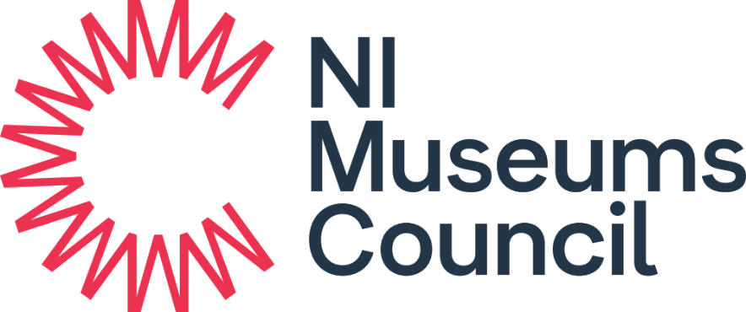

Playful Museums Festival Grant 2025-2026

GUIDELINES FOR APPLICANTS

Application, Project Completion and Evaluation Forms are available at www.nimc.co.uk

Please email completed applications to info@nimc.co.uk by 12pm on 10 October 2025.

Decisions: November 2025

Please note that all projects must be completed by before Saturday 1 March 2026. If you are unable to meet these conditions, you should NOT apply to this scheme as NIMC will not meet any costs incurred beyond this period.
About
This grant scheme aims to support activities that promote playful museum spaces, and programming for children under 5. All grant-funded activities should take place during February 2026 to coincide with the Playful Museums Festival.
The Playful Museums Festival Grant prioritises applications which clearly demonstrate that:
- The activity is specifically targeted to meet the developmental needs of babies,
toddlers or pre-schoolers under the age of 5.
- The activity is designed to create a long-term impact for both the attendees and the museum.

NIMC is keen to support new programmes of work and can provide advice and guidance to those museums making a first-time application, as well as those that are new to early years programming.
NIMC is also committed to sustainable programming and will seek to support applications that build upon previous Playful Museum projects.
It is advisable that you discuss your application with NI Museums Council (NIMC) Development Officer - Catherine Doran catherine.doran@nimc.co.uk, in advance of submission.

Deadlines
Complete applications must be submitted by email to info@nimc.co.uk by 12pm on Friday 10 October 2025. Late applications will not be considered.
If a grant offer is made, you must return a signed Offer Acceptance within one calendar month of the date of the offer. NIMC cannot always honour offers where your Acceptance has been received after this date.
All events/purchases must be completed before Saturday 1 March 2026, and all paperwork, monitoring and grant drawdown finalised, by Friday 13 March 2026. The grant may be withdrawn after this date.

Am I Eligible?
The NIMC Playful Museums Festival Grant Programme is open to UK Accreditation Scheme Accredited (Full or Provisional) non-National museums in Northern Ireland who are currently members of NIMC.
NIMC supports non-Accredited museums and collections by providing training, advice and guidance. You should be a member to access these services. To join, please visit www.nimc.co.uk.

How Much Can I Apply For?
Each museum can apply for up to £500.
Should NIMC receive more fundable applications than it can support, we may offer to fund a proportion of the costs requested.

Match Funding
No match funding is required but we appreciate being informed of any other funding sources or in-kind contributions.

What You Can Apply For
Examples of what the fund can cover:
- Facilitator costs (selecting a facilitator with experience of engaging with under 5s is advisable).
- Costs associated with both development and delivery of project, including consultations with target audiences.
- Travel costs associated with museum staff undertaking outreach activity.
- Travel costs associated with nurseries, Sure Starts etc. travelling to the museum.
- Resources, such as objects for handling boxes, sensory items, books, puzzles, toys, craft items, signage, equipment (chairs, nappy changing, mats, cushions, table or trolley).
- Online resources.
- Creation of under 5s activity space.
- Training for staff and volunteers.
- Costs associated with formative and summative impact evaluation.
- If you have other ideas that aren’t listed above, please reach out to discuss in advance of submission.

What the fund does not cover
- Staff time.
- Conservation of museum collections.
- New displays, exhibitions, and interpretation.
- Costs associated with any activity or expenditure that has already taken place; or a project that has already started.
- Organisational debt.

How will we evaluate your application?
Applications must be
- Deliverable within the required timescale.
- Fully and appropriately costed.
- Able to agree to the terms and conditions of the grant award.

This fund prioritises applications which clearly demonstrate that:
- The activity is specifically targeted to meet the developmental needs of babies, toddlers and/or pre-schoolers under the age of 5.
- The activity is designed to create a long-term impact for both the attendees and the museum.

There are four questions in your application that will be assessed and scored.
Assessment Scoring | Marks Available
Q1. Project description and delivery | 20
Q2. Impact your activity will have based on your outcomes | 30
Q3. How project meets the Playful Museums Festival priorities | 30
Q4. Evaluation of development and delivery of the project | 20
TOTAL | 100

Addressing the assessment Criteria
Q1. General Description and project delivery
Please provide details of the activity including when, how and who it will be delivered by and if you will require materials to assist with this delivery.
Q2. Impact your activity will have based on your outcomes
Please tell us how the project will make a difference to your museum. You should provide a clear rationale for the project and how it will impact on the museum. This section is an opportunity to establish the need for the project and provide targets and outcomes. Projects which provide strong supporting evidence and good base line information will be assessed favourably.
Q3. Please outline how your project meets the priorities of the Playful Museum Festival Scheme
Please describe how your project will meet the priorities of the Playful Museum Festival Grants Programme
- The activity is specifically targeted to meet the developmental needs of babies,
toddlers or pre-schoolers under the age of 5.
- The activity is designed to create a long-term impact for both the attendees and the museum.
Q4. Evaluation of development and delivery of the project
This section should outline the proposed increase in engagement, detail your target audiences and outline any desired learning outcomes from activities. You should consider how you will evaluate the success of your project with your audiences.

Conditions of Funding
- NIMC will not pay VAT on any expenditure incurred by VAT registered organisations with the ability to reclaim VAT costs.
- Remember that the grant will be paid retrospectively on production of a project completion form and invoices/receipts.
- Once awarded, grants cannot be increased.
- Applicants must be in a position to comply with any conditions attached to the grant that may be included in the Letter of Offer. NIMC must be notified immediately if the applicant encounters any problems in complying with the conditions.
- Applicants must be in a position to deliver the project within the agreed timescales. NIMC must be notified immediately of any delay or anticipated delay. Should NIMC consider any delay to be unacceptable, the grant may lapse and any payments made may be recovered in whole or in part.
- Applicants must comply with the expenditure, receipting, evaluation and monitoring conditions stated in the contract for funding.
- Any person authorised by NIMC including the Department for Community’s Internal Audit Unit and the Northern Ireland Audit Office shall have rights of access to asset and accounting records in respect of any assistance provided.
- A Project Evaluation Form must be submitted 3 months after project completion.

How do I apply?
Complete the NIMC Playful Museums Festival Grant Application Form in full.
Email the application to info@nimc.co.uk by 4pm on Friday 17 October 2025.

What will happen next?
We will acknowledge your application by e-mail within three working days.
NIMC staff will write an assessment of the application, based on the Playful Museums Festival Criteria listed on page 4. We may contact you to discuss the application in more detail during the course of our assessment.
The Assessment will be approved by the NIMC Grants Committee and authorised by the NIMC Board. We will tell you by email of the decision as soon as possible thereafter.

What information will I need to submit to claim the grant?
The grant will only be paid against actual expenditure described and itemised within the application.
The grant will only be paid once we have received:
- Invoice from your governing body to NIMC for the correct amount. The figure on this should be 100% of the actual expenditure or the total amount NIMC has offered, whichever is the lower amount.
- Receipts for expenditure.
- Proof that you have paid for the item(s). Acceptable proof of payment will be bank or credit card statements, proof of online banking transfer, BACS payment records, and copies of cheques.
- Project Completion form is submitted.
The financial paperwork should be sent to info@nimc.co.uk / Northern Ireland Museums Council, 153 Bangor Road, Holywood, Co Down BT18 0EU

Project Completion Form
Submitting a project completion form is a condition to the offer of a grant and is required prior to payment. This will include:
- Completion of the NIMC Museum Collections Grant Monitoring Form.
- Provision of at least one good quality image of 1MB or above that NIMC can use for publicity purposes and on www.nimc.co.uk
Please send the completed project completion form, by email to info@nimc.co.uk.

Project Evaluation Form
A project evaluation form must be submitted 3 months after the project’s completion.
Please send the completed project evaluation form, by email to info@nimc.co.uk.

Case Studies
We may use your successful grant as a Case Study on our website to publicise your museum, NIMC and the sector overall.

Acknowledgement
NIMC expects that its support towards the grant purchase is acknowledged through the incorporation of the Council’s logo and any social media posts.

VAT and Safeguarding
Successful applicants must provide:
- Written confirmation of your VAT status i.e., whether or not the grant recipient is registered with HMRC and can/cannot reclaim VAT on expenditure relating to this project.
- Written confirmation that the grant recipient has an up-to-date safeguarding policy that has been approved by its governing body.

Data Protection Act 1998 and Freedom of Information Act 2000
NIMC values the right to personal privacy. We collect and hold personal data in order to successfully deliver our business and in order to comply with our statutory obligations. The personal data you provide on this form may be held by us electronically and in hard copy but will only be used in accordance with the Council’s Data Protection Policy and the Data Protection Act 1998.
This information may be subject to release to others in accordance with the Freedom of Information Act 2000. However, certain exemptions from release do exist, including where the information provided is protected under the Data Protection Act 1998.
Reports and summary information from the information you supply and from comments made on your application by staff members are likely to be held on both our paper and electronic systems and will be made available to those deciding upon this and any other grant applications you make.
By submitting your application, you waive any right to raise any type of proceedings against the Northern Ireland Museums Council as a consequence of, or in contemplation of, any disclosure of the contents of your application in response to an information request made under the Freedom of Information Act 2000.
We view your signature on your application form as acceptance of the use of your data as outlined above.
Information on NIMC’s policy on data protection, its Publication Scheme, and on how to access information held by the Council is available through www.nimc.co.uk, or by contacting us directly.

