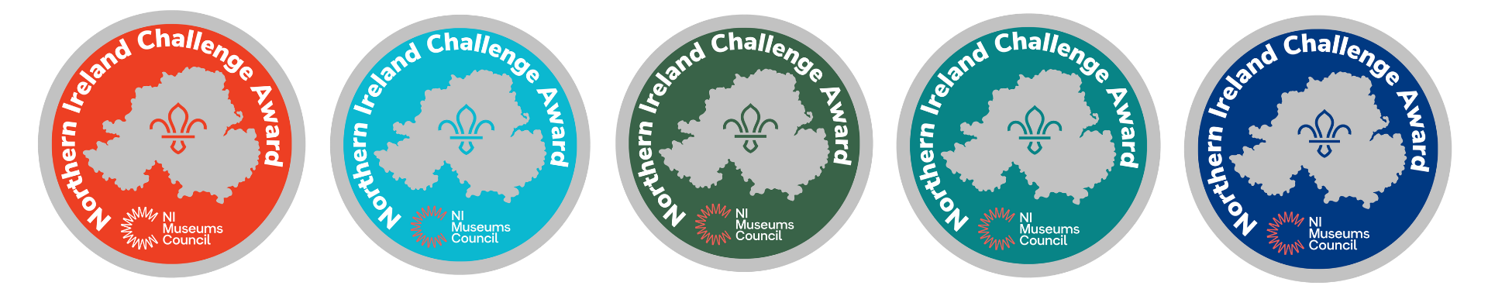
NI Challenge Badge sponsored by NI Museums Council – Overview and Guidance
NI Museums Council (NIMC) and Scouts NI are delighted to announce that we are collaborating to create and implement the NI Challenge Badge sponsored by NI Museums Council for Scouts NI members. This project aims to encourage Scouts to engage with local museums through a structured badge program, promoting educational, cultural and fun experiences in their local museums.
NI Challenge Badge Project Objectives
- To strengthen relationships between local museums and the scouting community in Northern Ireland.
- To create a new NI Challenge Badge sponsored by NI Museums Council for Scouts NI, rewarding visits to museums and completion of related activities.
- To raise awareness of the value of local museums within the scouting community.
- To provide flexible, age-appropriate activities that can be completed by Scouts individually or as part of their group.
- To evaluate the impact where possible of the project on museums and participants.
What is the NI Challenge Badge?
Scouts NI are redeveloping their NI Challenge Badge to now include a compulsory museums element. The badge will be available to all sections of Scouts NI, from Squirrels (ages 4-6) to Network (ages 18-25).
- The badge can be earned by completing a number of activities out of 34 optional and two compulsory activities, including one compulsory museum-based activity.
- To complete their compulsory museum activity scouts will be directed to a list of local museum and details of the eligible activities that scouts can engage in either as a group or on individual visits.
- Once a scout completes the activity, they will provide their scout leader with evidence they have completed the museum activity element of the NI Challenge. Once they have met all the activity requirements of the Challenge award, they will receive their badge from Scouts NI.
- NIMC have worked with Scouts NI as they designed the badge, and NIMC are procuring the first batch of tapestry badges for each of the five scout sections.
- As with other Scouts badges, a nominal charge will be paid by scouts to receive badges, this will then go towards making the NI Challenge badges self-sustaining after this initial batch.
- The project will be due to launch in Spring 2025 (likely 30 April) coinciding with the beginning of the Scouts camping year.
How do museums get involved?
NIMC member accredited museums now can promote pre-existing or specially designed activities through the NI Challenge badge program. Read this guidance first then submit the NI Challenge Museum Participation Form to eva.lynch@nimc.co.uk before 7th March 2025.
We understand that staff capacity and resources in our local museums is limited, and so we want to be flexible and pragmatic as to what the activity is.
We’re asking museums to put forward (ideally) pre-existing activity related to a museum’s permanent collection. This means that the activity stays current on a long-term basis and will be unlikely to require additional resource from the museum. Scouts can do the activity on their own with family or with their scout group, so you can bear this in mind when proposing activities. If your museum would have staff capacity to require the scouts to engage with staff on part of their visit please do encourage this, but if that is not possible the activity can be designed to be self-guided and self-evidenced. By the end of their museum visit, participants should be able to collect some type of evidence to prove they have completed the activity e.g. a completed trail sheet, a certificate provided by museum upon completion, or a photograph that shows them engaged in the activity.

e.g. if a museum has a pre-existing trail or activity pack available, then the participant might receive a certificate on completion (if museum staff capacity and resource allow) or takes the completed trail/activity sheet with them, or takes a photo to their leader as evidence that they have completed the activity.

As there will be five sections of scouting participating in the NI Challenge, differentiated by age groups, we ask that where possible you offer an activity suitable for each section (age ranges outlined on form). Activities may be more involved as the section ages increase; tough some activities may be transferrable to more than one section.

NIMC will act as the main contact for participant local museums and liaise with Scouts NI to ensure activity information is appropriate and available via the Scouts NI website for the launch of the NI Challenge Badge. NIMC and Scouts NI hope to work with local museums to arrange the launch and promotion of the NI Challenge Badge sponsored by NI Museums Council, and so the form also asks about your interest/ability in contributing to that.

We want this project to have impact across NI and encourage engagement in as many of our accredited local museums as possible. Complete the form so that your museum is involved in this exciting new audience development opportunity!

Please return the NI Challenge Museum Participation Form to eva.lynch@nimc.co.uk by 07.03.2025. Please get in touch if you would like to discuss this opportunity further.

