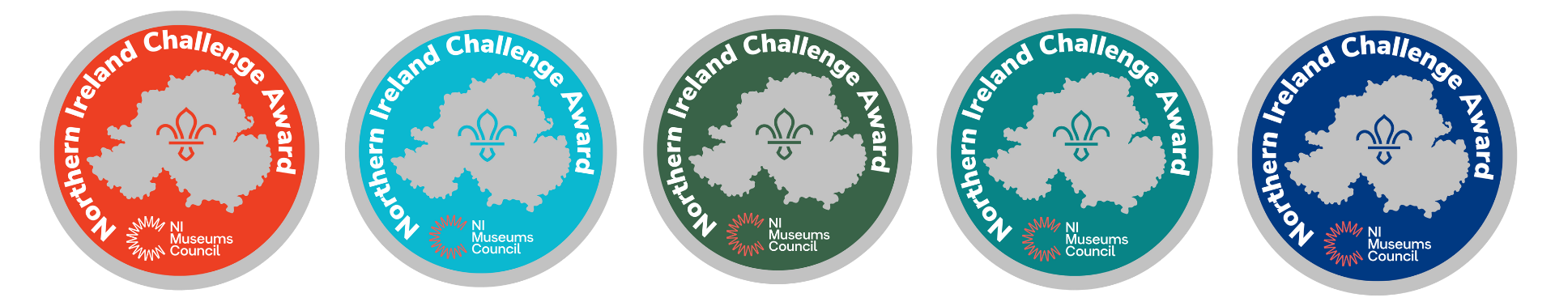
NI Challenge Badge sponsored by NI Museums Council – Museum Participation Form
1. | Museum Name
2. | Address
3. | Website
4. | Museum representative contact details for NIMC/Scouts NI
5. | Opening hours/arrangements
6. | Ticketing
7. | Can you offer a discounted ticket for NI Scout members completing this Challenge? | Yes/No/Not applicable. Further details:
8. | Contacts details for making bookings if necessary.
9. | Would you be available to welcome a group of scouts for a photocall at your museum between 1st and 14th April? | Yes/No. Further details:
10. | Do you have an existing relationship with any scout groups? | Yes/No. Further details:

11. Please complete the table with suggested activities for each section (age group) that would be available in your museum for participants to complete on an ongoing basis. If there is an age group that you are not sure what activity to suggest, please note this and we can work on this with you to develop something or work around.
Section | Core age range | Minimum age | Maximum age | Suggested Activity e.g. complete the museum's 'Flaxy trail', or 'find the museum's exhibit built out of sugar- design what other local sites you might exhibit in a fantasy display, what other unusual materials could you use?’ | Suggested Evidence to Bring to Scout Leader e.g. completed trail sheet, certificate, photo of participant engaged in activity.
Squirrels | 4th to 6th birthday | 4th birthday | 6½ years
Beavers | 6th to 8th birthday | 5¾ years | 8½ years
Cubs | 8th birthday to 10½ years | 7½ years | 11th birthday
Scouts | 10½ years to 14th birthday | 10th birthday | 14½ years
Explorers | 14th to 18th birthday | 13½ years | 18th birthday
Network | 18 to 24 | 18 years | 24 years | e.g. volunteering opportunities.
Please return this form to eva.lynch@nimc.co.uk by 07.03.2025. Please get in touch if you would like to discuss this opportunity further.

