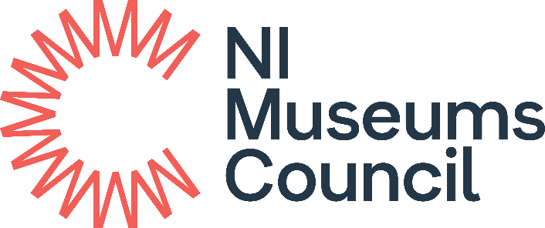

Playful Museums Festival Grant
Supported by Art Fund

APPLICATION FORM
2024-25

Before you apply
It is strongly recommended that you discuss your proposed application in advance with Catherine Doran, catherine.doran@nimc.co.uk

Office Use
NIMC Ref No:
Application received by email
Signed Hard Copy received

Playful Museums 2024-25

Criteria
The Playful Museums Festival Grant prioritises applications which clearly demonstrate that:

- The activity is specifically targeted to meet the developmental needs of babies,
toddlers or pre-schoolers under the age of 5.
- The activity is designed to create a long-term impact for both the attendees and the museum.

Please note you will be asked to report on the numbers benefiting from the planned activity. These should be recorded as under 5s, children aged 5 and over and adults.

The responsibility lies with the applicant to clearly demonstrate how their application meets the criteria. Please read the Guidelines for Applicants before completing this form.

VAT
Please note:
- VAT-registered museums should show both the VAT and exc. VAT amount for reference, but only claim for amount excluding VAT.
- Those not registered for VAT should show all costs inclusive of VAT and can claim for the total amount.

Match Funding
Match funding is not required but we would appreciate it if you could inform us of any other funding, core spend or in-kind contributions. This information is requested by our funders.

Please expand any section within the form should you need to do so.

- ELIGIBILITY CRITERIA
Is your Museum Accredited? |  | Yes / No
Is your museum a member of the NI Museums Council |  | Yes / No
- APPLICANT DETAILS
Name of Museum
Governing Body
Lead Contact for Application
Job Title / Role in Museum
Secondary Contact for Application
Job Title / Role in Museum
Museum Address
Postcode
Telephone (for both primary and secondary application contacts)
Email (for both primary and secondary application contacts)
Website
Facebook, Twitter etc.
Amount applied for. | £

- PROJECT DETAILS
  - Project title
  - Project description. Please outline the planned project. You should detail who, what, where, when, and why in terms of project involvement and delivery. (Max 200 words)
  - What are your outcomes for this funded activity? Please note, this is the impact your activity will have, not the list of outputs. (Max 200 words)
  - Please outline how your project meets the key priority of the Playful Museums Festival Grant (see Grant Guidelines and above). (Max 200 words)
  - What methods will you use to evaluate both the development and delivery of the project? What formative and summative measures will you use to assess the impact of the funded activity? (Max 200 words).
  - Who will be responsible for delivering the project and managing the funding?
  - What is the estimated timescale of the funded activity? When will it start and end?

- Grant Funding Breakdown
- Overall cost of the project |  | £
- Grant value applied for  How much funding are you seeking from the Playful Museum Festival Grant? |  | £
- Match funding amount  How much funding is the museum contributing towards the project? |  | £
- Is the museum VAT registered? |  | Y/N
- Breakdown of project costs  Provide an indicative list of all the project costs including the specialist services/ materials/ or equipment required to deliver the project. Continue a separate sheet if necessary.  Please note:  VAT-registered museums should show both the inc. VAT and exc. VAT amount for reference, but only claim for amount excluding VAT. Those not registered for VAT should show all costs and claim inclusive of VAT. |  | £
TOTAL Costs claimed for
- Match Funding Breakdown  What cash or in-kind resources will you be contributing to this project? |  | £
Costed staff time | Y/N
Costed volunteer time | Y/N
Contribution from core budget | Y/N
Transport costs | Y/N
Venue costs | Y/N
TOTAL costs

DATA PROTECTION AND GDPR
The data you provide on all paperwork related to this grant may be held by us electronically and in hard copy. At NIMC we are committed to protecting your privacy and security. Please read our Privacy Notice at www.nimc.co.uk which explains what information we collect about you and how we treat that data.

Agreement
All successful applicants will receive a formal Grant Letter of Offer and must agree to the following terms:
- Use the award for the approved purchases only
- Inform us immediately if you are unable to spend all or part of the fund
- All information supplied in the application form, and in any accompanying documents, is true and accurate
- Information provided in the application form, and any accompanying documents, may be made available to other departments/agencies for the purposes of preventing or detecting fraud
- Complete the NI Museums Council’s Project Completion Form
- To submit a Post Project Evaluation within 3 months of completion of the project. (A template is available from NIMC on request).
- To acknowledge the Playful Museums Festival Grant funding from NI Museums Council on all print and online marketing materials using the wording and logo we will provide
- To complete all activity expenditure by 1 March 2025
- To forward a copy of all receipts, statements, and invoices to NI Museums Council by 1 March 2025

Please note
The deliberate submission of falsified information will lead to the NI Museums Council withdrawing the application, or if a grant had already been awarded, to ask for repayment of any funds already paid. Such a situation will also have implications for any future applications the organisation may submit.

The maximum amount that you can apply for is £500. An organisation may only apply to the Playful Museums Festival Grant programme once in any financial year.

Sending applications by email
- Ensure that your subject line does not contain any full stops or commas
- Ensure that attachment do not contain any full stops or commas within their name for example in a date (file extensions are acceptable for example .docx)
- We can accept Word, Excel and PDF files

Declaration of Applicant

This section must be signed by the CEO / Chair / Director / Manager / lead officer of the museum or Head of Museum Service.

I have received and read the Guidelines relating to the Northern Ireland Museums Council’s Grant Programme and accept the conditions therein.

I can confirm that the information given in this application and in all supporting documentation is accurate.

[Please note that if you deliberately give any false or misleading information, we will withdraw your application or, if a grant has already been awarded, ask you to pay back any money we have given you. This will also have implications for any future applications you may submit.]

I confirm that this item will be accessioned as part of the Museum’s permanent collection.

Name: ____________________________________________________________

Signed ___________________________ Date ____________

Job Title / Role: ____________________________________________________

On behalf of _____________________________________________________

Please complete the Application Form with reference to the Guidance Notes.
Please send the completed form to info@nimc.co.uk by 18th October 2024
Late applications will not be considered.

We will acknowledge receipt of your application within one working day. If you have not heard from us after this time, please contact us immediately.

