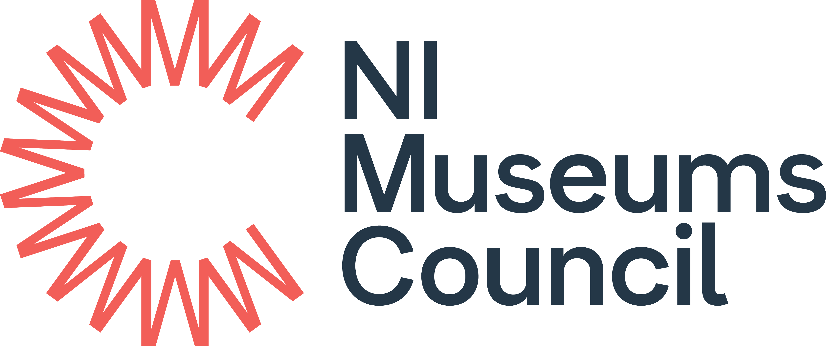

Accreditation Scheme for Museums and Galleries in the United Kingdom:
Eligibility questionnaire

November 2018

Main contact:

Title:

First name:

Last name:

Job title/position:

Correspondence address

Postcode
Telephone number:

Email address:

Please indicate whether these details are personal or business:
Personal |  | Business
For reasons of speed and cost we prefer contact by email. If you would prefer contact by post – please tick here:

On completion of the form, to be signed by a member of the governing body or by an individual, authorised to sign on behalf of the governing body.

Signed:

Name:

Position:

Date:

Data Protection
Any personal information you provide will be used purely for the purpose of determining whether the museum you represent can apply for Accreditation. No personal information provided will be published unless as otherwise required by law and all data will be handled in accordance with the General Data Protection Regulation and the Data Protection Act 2018. For more information contact devofficer@nimc.co.uk or see Northern Ireland Museums Council’s Privacy Policy www.nimc.co.uk/privacy-policy/

- Is the museum based in the UK, Isle of Man or Channel Islands?

Yes/No

Name of museum:

Museum address including postcode:

- Does it meet the agreed definition of a museum?

The Museums Association definition of a museum (1998) defines a museum:

“Museums enable people to explore collections for inspiration, learning and enjoyment. They are institutions that collect, safeguard and make accessible artefacts and specimens, which they hold in trust for society”

Yes/No

Please describe briefly how your organisation meets this definition (max 300 words)

- Is the museum a physical site/space/building which is open to the public regularly

Briefly describe the museum’s opening arrangements (max 300 words)

- Are the public able to see and engage with the museum’s collections?

Please outline how this takes place (max 300 words)

- The museum must have an appropriate constitution

Name of governing body

The constitutional entity must legally mean that the museum:
- Exists for public benefit
- Can demonstrate its collections and assets are appropriately protected
- Has powers to operate a museum and hold collections and assets, these powers must be transparent and should not include the ability to distribute assets or profit for private gain
- Is subject to statutory regulation or judicial process in relation to its conduct
- Must be a permanent entity with a long-term purpose

What type of constitution does your organisation have?

Act of Parliament
Royal Charter
Local Authority
University
Charitable Trust
Charitable Company
Charitable Incorporated Organisation & Scottish Charitable Incorporated Organisation
Community Interest Company
Benefit of Community Societies
Unincorporated Association
Other
If you selected Other, please expand here

Please attach your museum’s current governing documents and briefly describe how they meet the constitutional criteria 1-5 above (max 500 words)

Please outline which regulatory framework your museum operates under. For example, who you are registered with or your appropriate regulator eg the Charity Commission/ Office of the Scottish Charity Regulator. (max 300 words)

Charity number: |  | Company number  if relevant:

Please confirm whether the governing body operates the museum directly or has contracted a separately constituted management organisation:

Directly managed Contracted

6. Commitment and timescales for making a full application for Accreditation

Please evidence your commitment to making a full application for Accreditation within a three-year period and outline your planned timescale. (max 300 words or via a cross-referenced attached document, eg Forward/business plan, letter from trustees etc)

