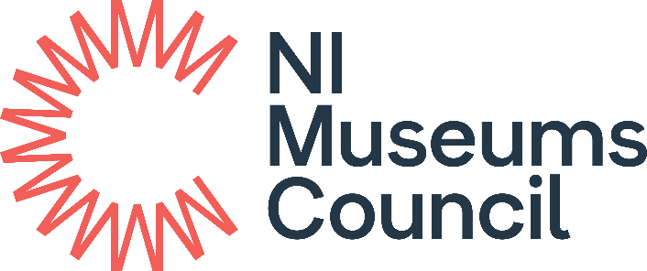

Playful Museums Festival Grant
Supported by Art Fund

APPLICATION FORM
2023-24

Before you apply

It is strongly recommended that you discuss your proposed application in advance with NIMC Development Officer - Catherine Doran: catherine.doran@nimc.co.uk

For Office Use Only
NIMC Ref No:
Application received by email
Signed Hard Copy received

Playful Museums 2023-24

APPLICATION FORM
The Playful Museums Festival Grant prioritises applications which clearly demonstrate that:

- The activity is specifically targeted to meet the developmental needs of babies,
toddlers or pre-schoolers under the age of 5.

Please review the Playful Museums Festival 2023-24 Guidance in full before preparing your application.

The responsibility lies with the applicant to clearly demonstrate how their application meets each of the criteria.

- ELIGIBILITY CRITERIA
Is your Museum Accredited? |  | Yes / No
Is your museum a current (fully paid) member of the NI Museums Council |  | Yes / No
- APPLICANT DETAILS
Name of Museum
Governing Body
Lead Contact for Application
Job Title / Role in Museum
Museum Address
Postcode
Telephone
Email
Website
Facebook, Twitter etc.
Amount applied for (clearly state VAT) | £

- PROJECT DETAILS
  - Title of Project
  - Project description. Please outline the planned project. You should detail who, what, where, when, and why in terms of project involvement and delivery. (Max 200 words) Assessment Value: 15
  - What are your planned outcomes for this funded activity? (Max 200 words) Assessment Value: 15
  - Please outline how your project meets the key priority of the Playful Museums Festival Grant (see the Playful Museums Festival Guidelines. (Max 200 words) Assessment Value: 20
  - How will you measure the success of the funded activity? Who will be responsible for delivering the project and managing the funding? (Max 200 words)
  - What is the estimated timescale of the funded activity? When will it start and end?

- Grant Funding Breakdown
- Overall cost of the project  Please make sure that overall cost is equal to the amount applied for in addition to any matched funding amount. |  | £
- Value of grant you are applying for  How much funding are you seeking from the Playful Museum Festival Grant? |  | £
- Matched funding amount  How much funding is the museum contributing towards the project? |  | £
- Is the museum VAT registered?  Please note: VAT-registered museums should show all costs and claims exclusive of VAT. Those not registered for VAT should show all costs and claims inclusive of VAT. |  | Y/N
- Project Costs Breakdown  Provide an indicative list of all the project costs including the specialist services / materials / equipment etc. required to deliver the project. Add additional lines and continue on a separate sheet if necessary. |  | £
TOTAL Costs

- Match Funding Breakdown  Please detail any cash or in-kind resources that you will be contributing to this project. Indicate whether this includes / excludes VAT. Add your own headers if required. |  | £
Costed staff time | Y/N
Costed volunteer time | Y/N
Contribution from core budget | Y/N
Transport costs | Y/N
Venue costs | Y/N
TOTAL costs |  | £

DATA PROTECTION AND GDPR
The data you provide on all paperwork related to this grant may be held by us electronically and in hard copy. NI Museums Council is committed to protecting your privacy and security. Please read our Privacy Notice at www.nimc.co.uk, which explains what information we collect about you and how we use and treat that data.

Agreement
All successful applicants will receive a formal Grant Letter of Offer and must agree to the following terms:
- Use the award for the approved purchases only.
- Inform us immediately if you are unable to spend all or part of the fund.
- All information supplied in the application form, and in any accompanying documents, is true and accurate.
- Information provided in the application form, and any accompanying documents, may be made available to other departments/agencies for the purposes of preventing or detecting fraud.
- Complete the NI Museums Council’s Project Completion Form.
- To submit a Post Project Evaluation within 3 months of completion of the project. (A template is available from NIMC on request).
- To acknowledge the Playful Museums Festival Grant funding from NI Museums Council on all print and online marketing materials using the wording and logo we will provide.
- To complete all activity expenditure by 1 March 2024.
- To forward a copy of all receipts, statements, and invoices to NI Museums Council by 1 March 2024.

Please note
The deliberate submission of falsified information will lead to the NI Museums Council withdrawing the application, or if a grant had already been awarded, to ask for repayment of any funds already paid. Such an eventuality will also have implications for any future applications that your organisation may seek to submit.

The maximum amount that you can apply for is £500, from a total available funding budget of £5,000. An organisation may only apply to the Playful Museums Festival Grant programme once in any given financial year.

Sending applications by email
- Ensure that your subject line does not contain any full stops or commas.
- Ensure that your attachment does not contain any full stops or commas within the filename (notwithstanding file extensions e.g. xxx.docx)
- We can accept Word, ODT, Excel and PDF file formats.

Declaration of Applicant

This section must be signed by two representatives of the applicant museum e.g. CEO, Chair, Director, Museum manager, Lead officer of the museum or Head of museum service.

The signatories below have received and read the Guidelines relating to the NI Museums Council’s Grant Programme and accept the conditions therein.

The signatories can confirm that the information provided within this application and in all supporting documentation is accurate and true.

[Please note that if you deliberately give any false or misleading information, we will withdraw your application, or, if a grant has already been awarded, ask you to pay back any money we have given you. This will also have implications for any future applications which you may seek to submit.

Name of applicant 1:

Job Title / Role of applicant 1:

Signature of applicant 1:

Date:

Name of applicant 2:

Job Title / Role of applicant 2:

Signature of applicant 2:

Date:

Please complete the Application Form with reference to the Guidance Notes.
Please send the completed form to info@nimc.co.uk by Friday 20th October.
Late applications will not be considered.

We will acknowledge receipt of your application within one working day. If you have not heard from us after this time, please contact us immediately.

