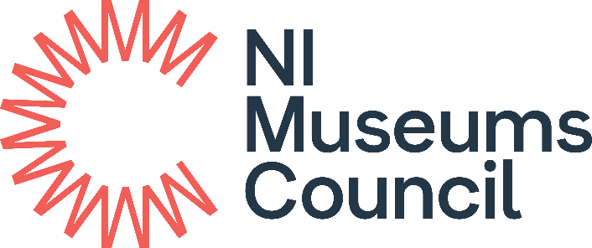

Collecting for the Future
Supported by Esmé Mitchell Trust

APPLICATION FORM
2023-24

Before you apply
It is strongly recommended that you discuss your proposed application in advance with Eva Lynch, eva.lynch@nimc.co.uk

Office Use
NIMC Ref No:
Application received by email
Signed Hard Copy received

Collecting for the Future

APPLICATION FORM
Please read the Guidelines for Applicants before completing this form.
Please expand any section within the form should you need to do so.
- ELIGIBILITY CRITERIA
Is your Museum Accredited? |  | Yes / No
- APPLICANT DETAILS
Name of Museum
Governing Body
Is the Museum VAT registered? | Yes/ No
Lead Contact for Application
Job Title / Role in Museum
Museum Address
Postcode
Telephone
Email
Website
Facebook, Twitter etc.

- PROJECT DETAILS
Item / List of Items (attach separate list if necessary)
Description of item or group (max. 500 words)
Date of item
Maker
Provenance (e.g. current ownership; date acquired by current owner; history of the item’s ownership etc.). Please ensure that you demonstrate that you have observed due diligence with regard to provenance.
Photograph
Please attach a recent photograph of the item to your application. This can be emailed separately or inserted here.

- CONDITION
Has the person named on p.2 personally inspected the item(s)? |  |  | Yes / No
Condition (Attach condition assessment report if available)
Conservation (If purchased do you have any plans for conservation?)
- VALUATION AND PRICE
Purchase Price (before discount) | £
Auctioneer’s Commission (if any) | £
Valuation
On what basis do you perceive the purchase price to be appropriate? (this may include, for example, auction records, recent valuations, etc.)
Museum Discount Secured? | Yes / No |  |  | Price after discount:  £
Amount You Are Applying For | £
Amount Applied for as a % of Final Price | %
Match Funding | £ / % |  |  | Source

- ACQUISTION DETAILS
Vendor | Name:  Address:  Email:  Tel:  Website:
Auction Sale? | Yes / No | Date of Auction: |  | Catalogue [give online catalogue web address]: | Lot No:
Proposed Purchase Date (if different from auction sale date) | (dd/mm/yyyy)
- COLLECTIONS DEVELOPMENT, CARE, MANAGEMENT AND USE
Please describe the relevance of the item to your Collections Development Policy*
Please describe how this item represents the culture and artistic achievements and experiences of this place thereby enriching and strengthening your collections*
Please describe how this item demonstrates strategic collecting in partnership with museum users and communities*
Please describe how the item(s) will be made accessible to the public (exhibition, publication, online, etc)*

* Criterion that will be scored.
Is it likely that any other Accredited Museum would be interested in acquiring the item? | Yes / No
If yes, provide details of the institution and whether you have consulted it in relation to the purchase.
Will the Museum be the sole owner of the item(s) once purchased? | Yes / No
Please confirm that the item will be accessioned as part of the Museum’s permanent collection? | Yes / No
How will you document the item?
Appropriate security measures in place?
Where will it be stored?
Websites / social media likely to be used to promote the acquisition and information about the item/ collection of items.

- DATA PROTECTION AND GDPR
The data you provide on all paperwork related to this grant may be held by us electronically and in hard copy. At NIMC we are committed to protecting your privacy and security. Please read our Privacy Notice at www.nimc.co.uk which explains what information we collect about you and how we treat that data.

- ENDORSEMENT & DECLARATION

You may e-mail your completed application to NIMC. But we require a signed copy of this endorse and declaration as well. You may provide this through a signed copy sent electronically to info@nimc.co.uk or through a hard copy sent to:

Northern Ireland Museums Council
153 Bangor Road
Holywood
BT18 0EU

Name of Museum _____________________________________________________

Item / List of Items for acquisition ________________________________________

Accreditation Mentor’s Endorsement to be completed only by museums with a Accreditation Mentor, as required under the Museum Accreditation Scheme

I endorse this acquisition as appropriate to the applicant museum and its Collections Development Policy

Name of Accreditation Mentor _____________________________________

Signed ___________________________ Date ____________

Declaration of Applicant

This section must be signed by the manager / lead officer of the museum or museum service.

I have received and read the Guidelines relating to the Northern Ireland Museums Council’s Grant Programme and accept the conditions therein.

I can confirm that the information given in this application and in all supporting documentation is accurate.

[Please note that if you deliberately give any false or misleading information, we will withdraw your application or, if a grant has already been awarded, ask you to pay back any money we have given you. This will also have implications for any future applications you may submit.]

I confirm that this item will be accessioned as part of the Museum’s permanent collection.

Name: ____________________________________________________________

Signed ___________________________ Date ____________

Job Title / Role: ____________________________________________________

On behalf of _____________________________________________________

