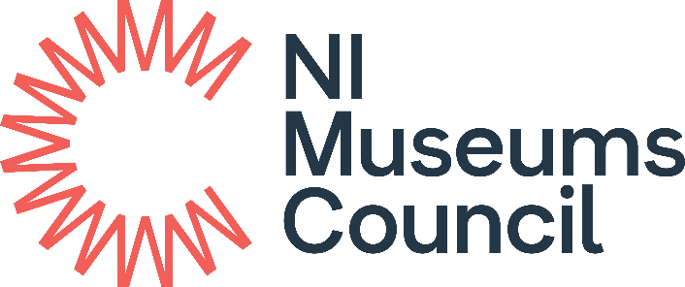

30 free individual annual memberships offered to celebrate 30 years of the NI Museums Council
Memberships will be awarded on a first come, first served basis until all the 30 memberships have been allocated. Membership lasts for one year and is open to new members only.
- Name:
- Contact Email:
- If employed, please indicate.
- Organisation:
- Job Title:
- Please indicate which category or categories that you identify with.
☐ Student
And / or
☐ Facing potential barriers related to disability, ethnicity, socio-economic background and/or gender identity or sexual orientation (LGBTQ+).
- If a student, please indicate.
- Institution:
- Course Title:
- Please provide a photograph or scanned copy of your student ID to identify as a current student.

Privacy Notice
NI Museums Council require this information to monitor uptake of the 30 for 30 memberships. The information you provide will be stored for the duration of the 30 for 30 memberships, after such time it will be deleted. Information will not be shared without your consent.

