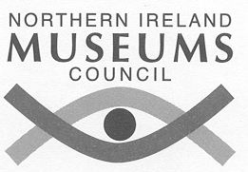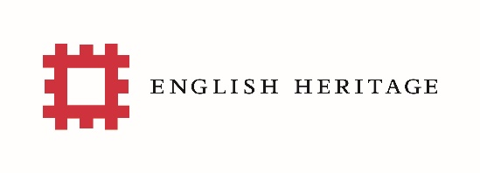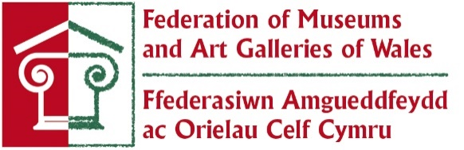
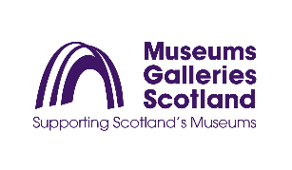
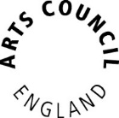
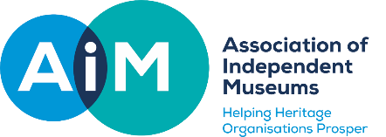
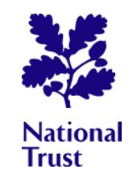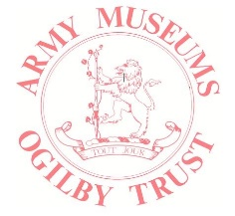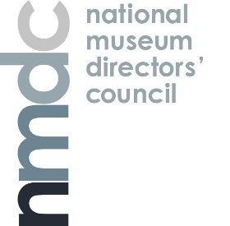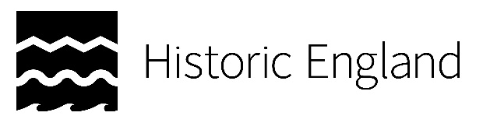

Statement on heritage, museums and collections at risk
Relevant funders alongside sector bodies have updated their co-ordinated approach in response to urgent situations when museums, archives, historic sites or collections are at risk. This joint statement sets out this commitment.

Arts Council England; the National Lottery Heritage Fund; Museums Association; Army Museums Ogilby Trust; the Association of Independent Museums; Collections Trust; English Heritage; Historic England; University Museums Group; Art Fund; National Museums Directors’ Council; National Trust; Museums Galleries Scotland; Northern Ireland Museums Council; The National Archives; Museum Development UK and the Welsh Museums Federation will work together to offer guidance to organisations which face a precarious future exacerbated by the impact of the Covid-19 pandemic.

The organisations supporting this statement wish to provide appropriate and timely advice in such situations, supporting governing bodies in their decision-making. However, the responsibility for the stewardship of the organisation, site and collections remains with the respective governing bodies and an effective response will depend on the willingness and ability of an organisation to take ownership of its issues.

We urge organisations, or individuals, who have concerns about the sustainability of a heritage organisation, museum or collection to contact the most relevant organisation, as early as possible. We commit to sharing information between relevant parties, if given permission to do so, so that we can determine who is best placed to help. We recognise that in some cases, there might be a need for confidentiality and more discreet conversations.

When approached with concerns, we commit to working in partnership. We will discuss appropriate responses. Our aim will be to help ensure the public retain long-term access to the collections held for their benefit.

Our joint response will take into account the circumstances of each case, recognising that organisations vary greatly in terms of the collections and buildings they manage, their purpose, their users, stakeholders and funders, business and governance models, scale of operation and income streams.

We recognise that it will not be possible to secure a long-term future for all organisations or collections. However, we believe that the chances of a positive outcome are greatly increased if there is timely and open discussion about the situation and if all appropriate organisations are involved in giving advice and support.

